VM Pig

Group 3 Tae Park, Hukai Luo, Xuanbo Huang

Q1 Store Sales

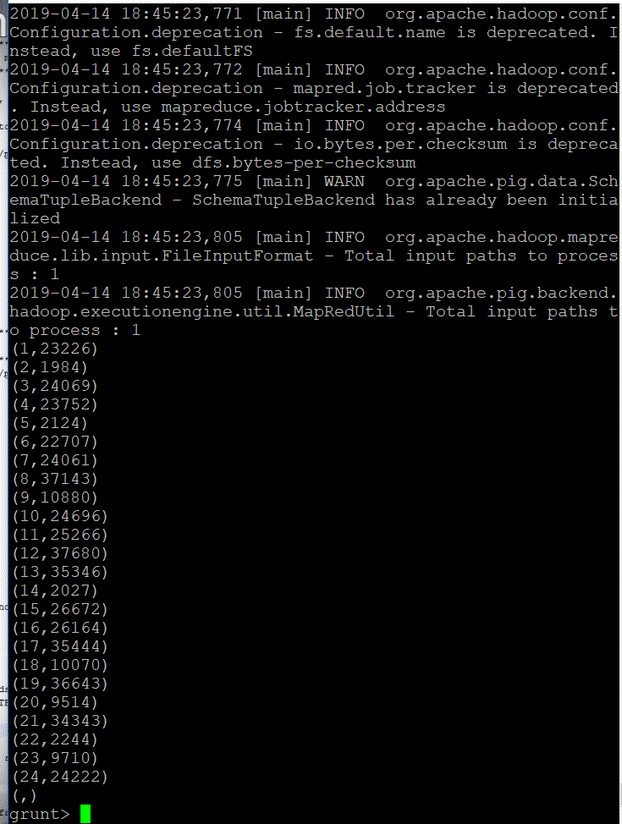

Q2 Sales Fact Group

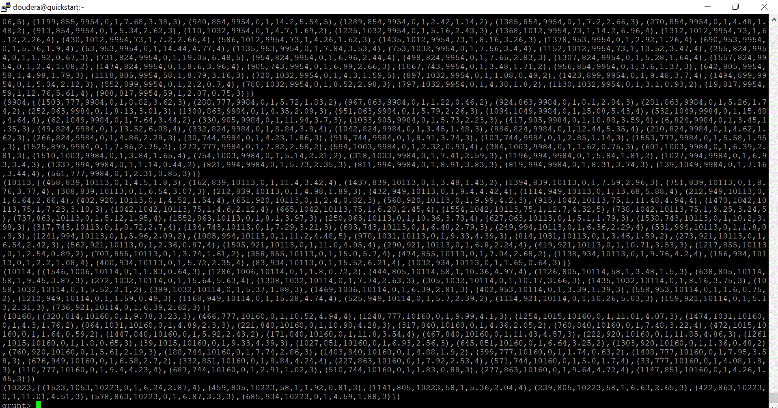

Q3 Sales Fact

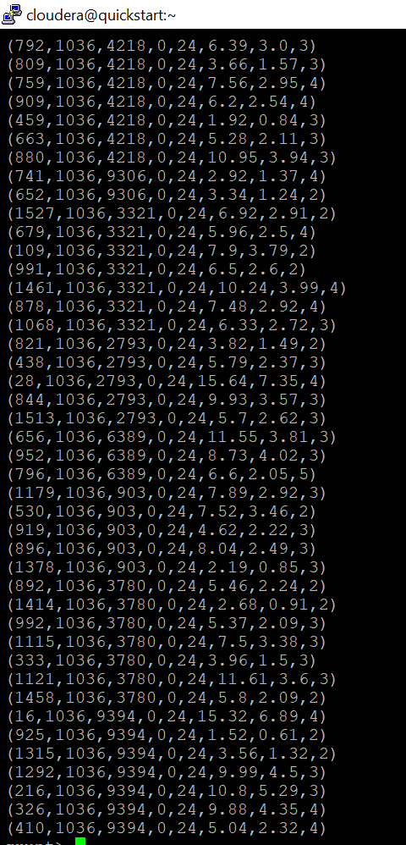

Q4 Set customer and filter $>1. Then Describe each column.

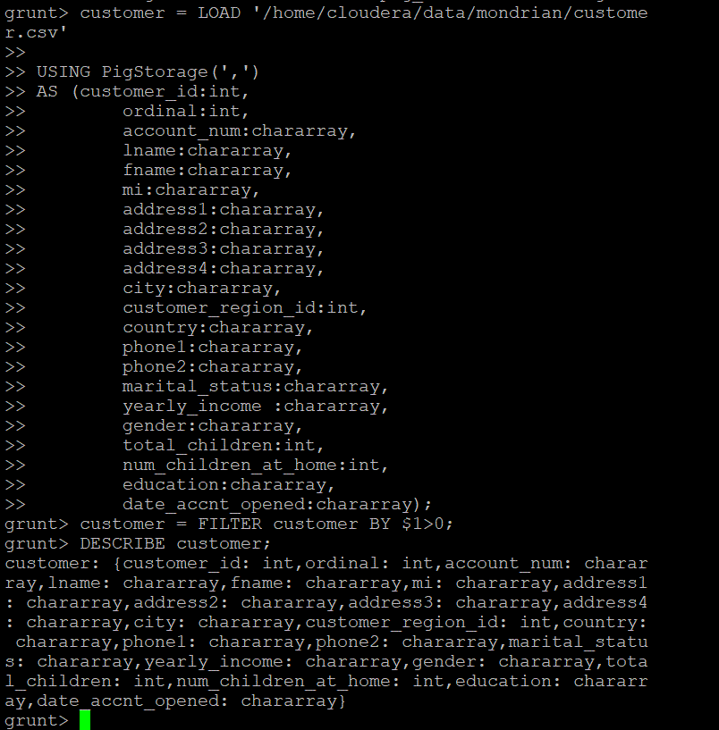

Q5. Sales Customer Join

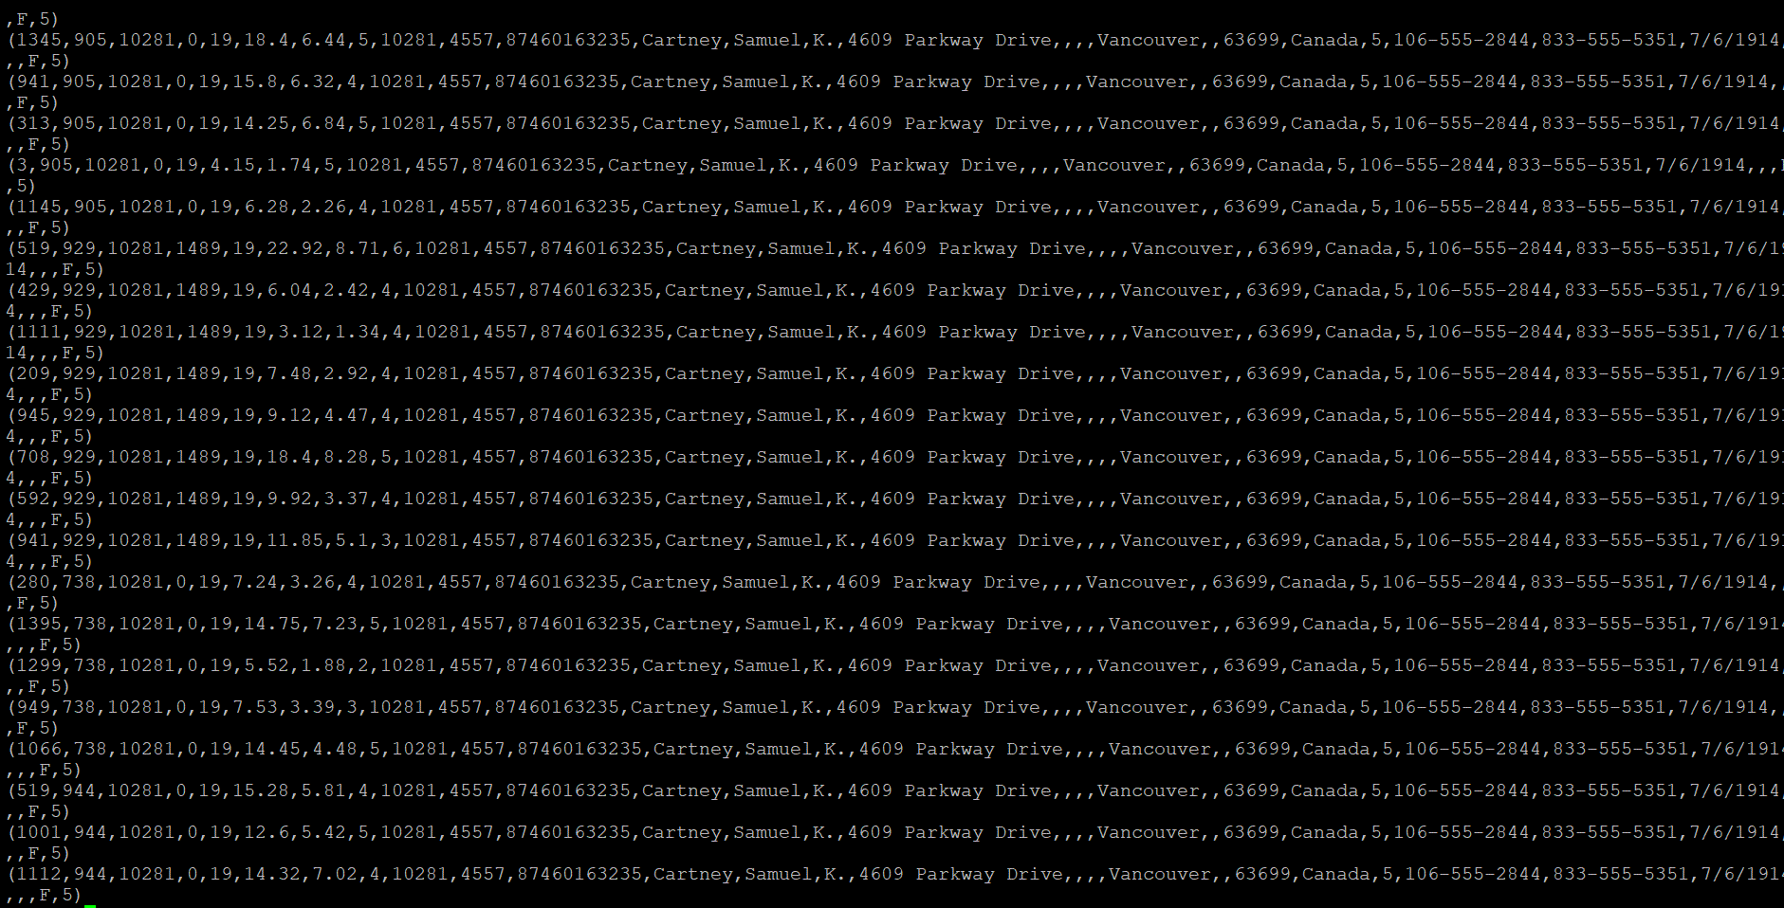

Q6 Sales Customer Join Sub. It shows everyone is married. Im not sure why.

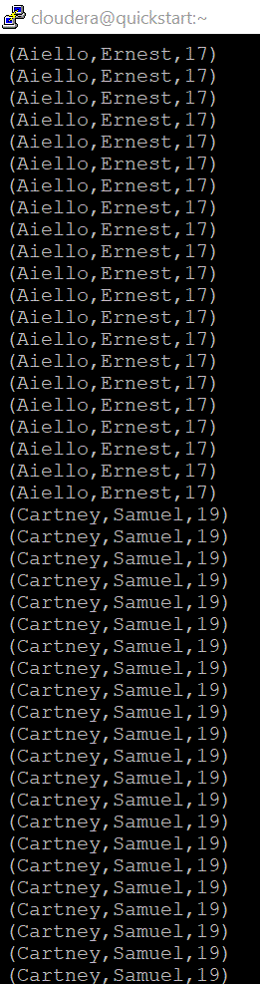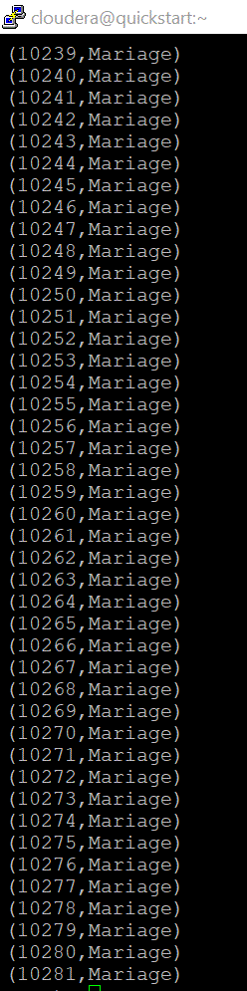

Q7 Indicator Variable for Male and Female. It doesn’t show male or female based on this indicator. I could not figure it out.

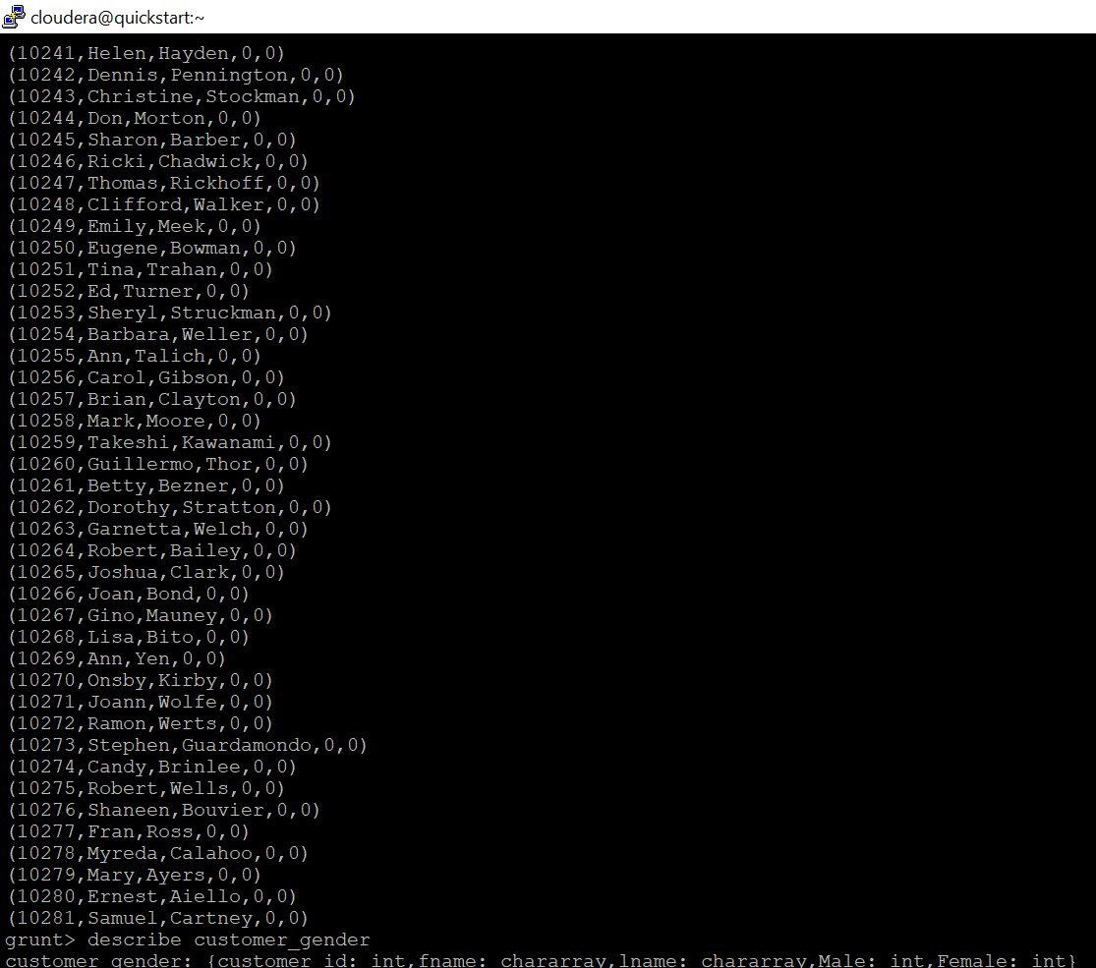

Q8 Normalized Sale

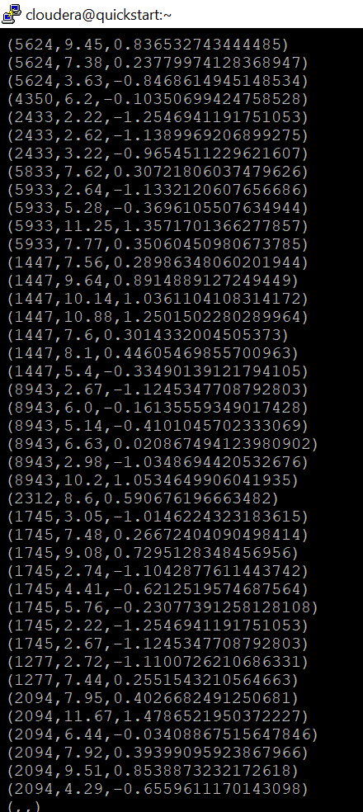

CODE

sales_fact = LOAD '/home/cloudera/data/mondrian/sales_fact_1998.csv'

Using PigStorage(',')

As

(product_id:int,

time_id:int,

customer_id:int,

promotion_id:int,

store_id:int,

store_sales:double,

store_cost:double,

unit_sales:int);

store_1_sales = FILTER sales_fact BY store_id==1;

sales_fact_group = GROUP store_1_sales BY customer_id;

DUMP sales_fact_group;

--Iterate and pulls out selected fields

sales_fact = FOREACH sales_fact GENERATE store_id, store_sales, store_cost, unit_sales;

DUMP sales_fact;

sales_fact_group = GROUP sales_fact BY store_id;

store_sales = FOREACH sales_fact_group GENERATE group, SUM(sales_fact.(unit_sales));

DUMP store_sales;

STORE store_sales INTO 'store_sales' USING PigStorage(',')

customer = LOAD '/home/cloudera/data/mondrian/customer.csv'

USING PigStorage(',')

AS (customer_id:int,

ordinal:int,

ccount_num:chararray,

lname:chararray,

fname:chararray,

mi:chararray,

address1:chararray,

address2:chararray,

address3:chararray,

address4:chararray,

city:chararray,

customer_region_id:int,

country:chararray,

phone1:chararray,

phone2:chararray,

marital_status:chararray,

yearly_income :chararray,

gender:chararray,

total_children:int,

num_children_at_home:int,

education:chararray,

date_accnt_opened:chararray);

REGISTER /home/cloudera/udf/dataProg.jar;

customer_status = foreach customer generate customer_id, dataProg.getStatus(marital_status);

DUMP customer_status;

-------------------------------------------

sales_fact = FOREACH sales_fact GENERATE store_id, store_sales, store_cost, unit_sales;

DUMP sales_fact;

##CREATE a group by customer name#####33

sales_fact_group = GROUP sales_fact BY store_id;

####Perform sum of value by customers###

store_sales1 = FOREACH sales_fact_group

GENERATE group, SUM(sales_fact.(unit_sales));

DUMP store_Sales;

STORE store_sales INTO 'store_sales' USING PigStorage(',');

fs -cat store_sales/*;

-------------------------CUSOMTER---------

sales_customer_join = JOIN sales_fact by customer_id, customer by customer_id;

DUMP sales_customer_join;

sales_customer_join_sub = FOREACH sales_customer_join GENERATE lname, fname, store_id;

DUMP sales_customer_join_sub;

-------------------UDF Registration-------------

REGISTER /home/cloudera/udf/dataProg.jar;

customer_status = foreach customer generate customer_id, dataProg.getStatus(marital_status);

DUMP customer_status;

-----------------Indicator Variable-----------

PAKCAGE

REGISTER /home/cloudera/udf/datafu-1.2.0.jar;

sales_mean = FOREACH(GROUP sales_fact ALL) GENERATE AVG(sales_fact.store_sales);

sales_std = FOREACH(GROUP sales_fact ALL)

GENERATE SQRT(datafu.pig.stats.VAR(sales_fact.store_sales));

cross_join = CROSS sales_fact,sales_mean,sales_std;

normalized_sales = FOREACH cross_join

GENERATE $2 as customer_id, $5 as store_sales,

($5-$8)/$9 as norm_store_sales;

DUMP normalized_sales;